Routing; class 2

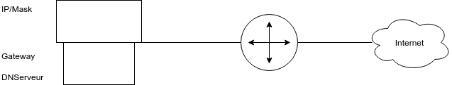

**DHCP :**

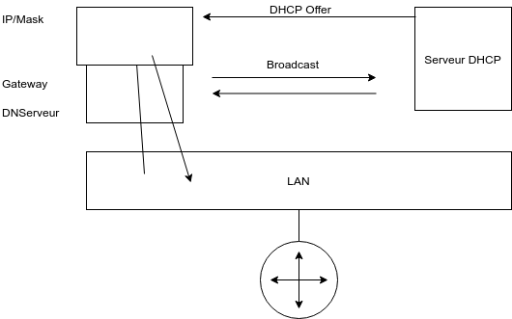

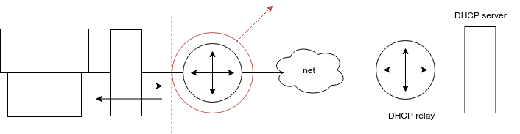

With this network, the limit of the broadcast is the router. You can’t forward the broadcast to the DHPC server this way. You have to use the DHCP Relay